Programs: Electrical & Computer Engineering

|  |  |
| --- | --- |
| Course Number | **ELE639** |
| Course Title | **Control** |
| Semester/Year | **Winter 2019** |
| Instructor | **Gosha Zywno** |

|  |  |
| --- | --- |
| **Lab Report No.** | **1** |

|  |  |
| --- | --- |
| Report Title | **Stability of Control Systems under**  **Proportional, PI, PD and PID Control** |

|  |  |
| --- | --- |
| Section No. | **06** |
| Group No. | **09** |
| Submission Date | **30/01/19** |
| Due Date | **30/01/19** |

|  |  |  |
| --- | --- | --- |
| Name | Student ID | Signature* |
| Abrar Ahsan |  |  |
| Vatsal Shreekant | 71363 |  |

(Note: remove the first 4 digits from your student ID)

*\*By signing above you attest that you have contributed to this submission and confirm that all work you have contributed to this submission is your own work. Any suspicion of copying or plagiarism in this work will result in an investigation of Academic Misconduct and may result in a “0” on the work, an “F” in the course, or possibly more severe penalties, as well as a Disciplinary Notice on your academic record under the Student Code of Academic Conduct, which can be found online at:*

[*www.ryerson.ca/senate/current/pol60.pdf*](http://www.ryerson.ca/senate/current/pol60.pdf)*.*

**Executive Summary**

This lab was designed to analyze and determine a safe array of controller gains that could be implemented across a variety of control systems before the system enters the unstable spectrum. In this lab, the behavior and stability of various control systems were observed. The systems that were analyzed are Proportional (P), Proportional-Integral (PI) and Proportional-Derivative (PD). The behaviour of each system was examined through SIMULINK simulations as well as mathematical calculations. All the systems were tested for Absolute stability by removing the inputs to the system and brining it to equilibrium. As for Relative stability, the transient was observed using the scope and how fast it settled down. Using the SIMULINK simulation for each system, the gain block value was adjusted every time so that the system reached marginal stability and was right on the brink of unstable system. This was done to maximize the number of controller gain array for each system and for the purposes of absolute precision. A gain margin of 4 was used for every simulation as a measure of relative stability.

For all the systems analyzed, both the simulation and the theoretical components were observed and calculated and thus comprised of the critical frequency oscillations, critical gain and the operating gain. The discrepancies in the Kcrit for Proportional Control, Proportional Integral and Proportional Derivative was 0.77%, 0.2% and 0.6% over the theoretical value respectively. All the discrepancies, however miniscule, are over the threshold and thus lead to the fact that while adjusting for marginal stability on the scope, the time axis was not large enough to observe that the system eventually became unstable and thus the envelope opened-up. It was observed that both gave similar results with acceptable deviance. Characteristics such as the wavelength and the critical gains were observed to rank their stability.

Table 1: Summary of Results

|  |  |  |  |  |  |
| --- | --- | --- | --- | --- | --- |
|  | **Simulation** | | **Theoretical** | |  |
|  | $ω_{osc}$**(rad/s)** | **Critical Gain** | $ω_{osc}$**(rad/s)** | **Critical Gain** | **Operating Gain** |
| **P** | 1.25 | 7.25 | 1.31 | 7.1946 | 1.798 |
| **PI** | 1.225 | 6.26 | 1.23 | 6.247 | 1.561 |
| **PD** | 2.64 | 9.85 | 2.61 | 9.79 | 2.447 |

## 1. Proportional (P) Control

### 1.1 SIMULINK Simulation

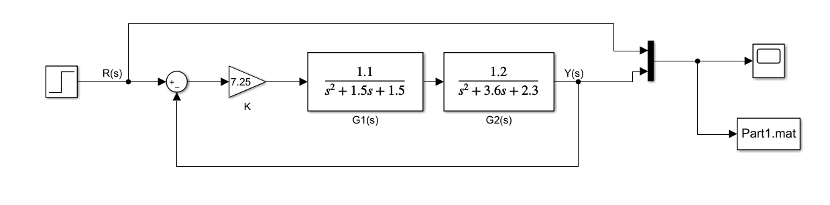

Figure 1: Proportional Control SIMULINK Simulation Diagram

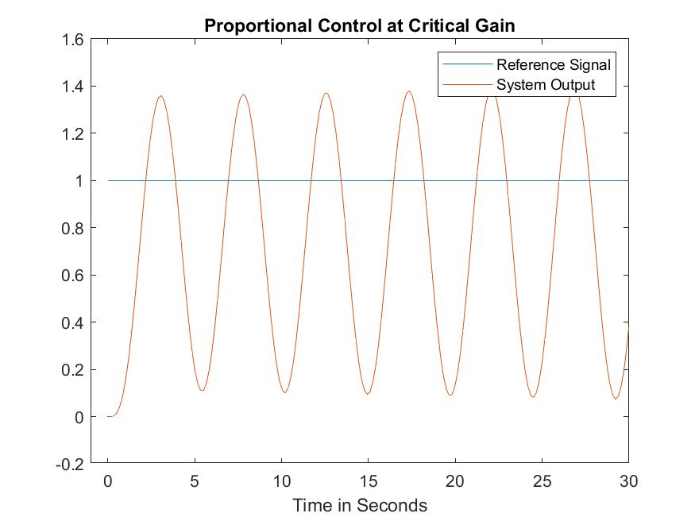

Graph 1: System under Proportional Control

$$K_{crit}=7.25$$

$$Frequency=0.199 Hz$$

$$ω=\frac{2π}{T}=\frac{2π}{5.003}$$

$$ω=1.25 rads/s$$

### 1.2 Theoretical Analysis

$$G_{1}\left(s\right)= \frac{1.1}{s^{2}+1.5s+1.5}$$

$$G_{2}\left(s\right)= \frac{1.2}{s^{2}+3.6s+2.3}$$

$G\left(s\right)= G_{1}\left(s\right) ×G_{2}\left(s\right)=\frac{1.32}{s^{4}+5.1s^{3}+9.2s^{2}+8.85s+3.45}$

The closed loop gain of a system $G_{CL}\left(s\right)$ is calculated below:

$$G_{CL}\left(s\right)= \frac{KG\left(s\right)}{1+KG\left(s\right)}= \frac{\frac{1.32K_{P}}{s^{4}+5.1s^{3}+9.2s^{2}+8.85s+3.45}}{1+\frac{1.32K_{P}}{s^{4}+5.1s^{3}+9.2s^{2}+8.85s+3.45}}$$

Simplified:

$$G_{CL}\left(s\right)=\frac{1.32K_{P}}{s^{4}+5.1s^{3}+9.2s^{2}+8.85s+3.45+1.32K_{P}}$$

The characteristic equation is: $s^{4}+5.1s^{3}+9.2s^{2}+8.85s+(3.45+1.32K_{P})$

The characteristic equation is applied in the Routh-Hurwitz array to solve for $K_{P_{CRIT}}$:

Table 2: Routh-Hurwitz Table for Figure 1

|  |  |  |  |
| --- | --- | --- | --- |
|  |  |  |  |
| $$s^{4}$$ | $$1$$ | 9.2 | $$3.45+ {1.32K}_{P}$$ |
| $$s^{3}$$ | $$5.1$$ | $$8.85$$ | $$0$$ |
| $$s^{2}$$ | $$7.46$$ | $$3.45+{1.32K}_{P}$$ | 0 |
| $$s^{1}$$ | $$\frac{48.42-6.73K_{P}}{7.46}$$ | 0 | 0 |
| $$s^{0}$$ | $${3.45+1.32K}_{P}$$ | 0 | 0 |

$$\frac{48.42-6.73K_{P}}{7.46}=0$$

$$K_{P}=\frac{48.42}{6.73}=7.1946$$

$$K_{P_{CRIT}}=7.1946$$

One of the necessary conditions is that $K_{P}>0$

This means $K_{P}$ has a range such that: $0<K_{P}<K_{P_{CRIT}}$

To find $ω_{OSC}$, the auxiliary equation must be found where $K_{P}=7.1946$

The value is placed into the Routh-Hurwitz Table:

Table 3: Routh - Hurwitz Table with $K_{P}$ Value

|  |  |  |  |
| --- | --- | --- | --- |
|  |  |  |  |
| $$s^{4}$$ | $$1$$ | 9.2 | $$12.94$$ |
| $$s^{3}$$ | $$5.1$$ | $$8.85$$ | $$0$$ |
| $$s^{2}$$ | $$7.46$$ | $$12.94$$ | 0 |
| $$s^{1}$$ | $$0$$ | 0 | 0 |
| $$s^{0}$$ | $$12.94$$ | 0 | 0 |

The $s^{2}$ row is used to create the auxiliary equation:

$$Q\left(s\right)= 7.46s^{2}+12.94=0$$

$$s= ±j1.31$$

$$ω_{OSC}= 1.31 rad/s$$

Lastly, to find the Operating Gain, $K_{OP}$, with a gain margin of $G_{mP}=4$, it is found to be:

$$K_{OP}= \frac{K_{P_{CRIT}}}{G_{mP}}= \frac{7.1946}{4}=1.798$$

$$K_{OP}=1.798$$

## 2 Proportional-Integral (PI) Control

### 2.1 SIMULINK Simulation

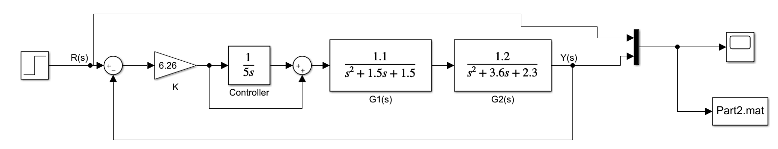

Figure 2: Proportional-Integral Control SIMULINK Simulation Diagram

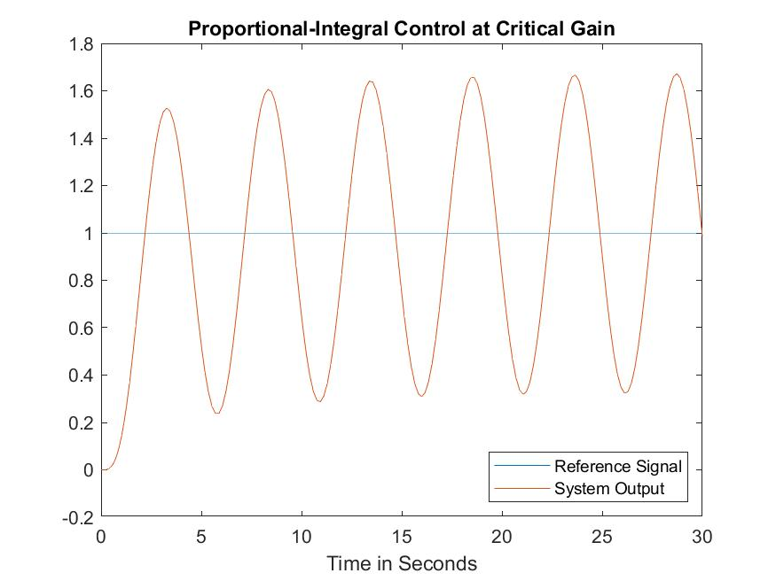

Graph 2: System under Proportional-Integral Control

$$K_{crit}=6.26$$

$$Frequency=0.195 Hz$$

$$ω=\frac{2π}{T}=\frac{2π}{5.124}$$

$$ω=1.225 rads/s$$

### 2.2 Theoretical Analysis

$G\left(s\right)= G_{1}\left(s\right) ×G_{2}\left(s\right)=\frac{1.32}{s^{4}+5.1s^{3}+9.2s^{2}+8.85s+3.45}$

This system has the same parameters as the Proportional Control except the change in Gain K.

where .

The closed loop gain of a system is calculated below:

Simplified:

The characteristic equation is: $5s^{5}+25.5s^{4}+46s^{3}+44.25s^{2}+17.25s+6.6K_{PI}s+1.32K_{PI}$

The necessary condition: $K_{PI}>0$

The characteristic equation is applied in the Routh-Hurwitz array to solve for $K_{{PI}_{CRIT}}$:

Table 4: Routh-Hurwitz Table for Figure 2

|  |  |  |  |
| --- | --- | --- | --- |
|  |  |  |  |
| $$s^{5}$$ | 5 | 46 | $$17.25+6.6K_{PI}$$ |
| $$s^{4}$$ | $$25.5$$ | 44.25 | $${1.32K}_{PI}$$ |
| $$s^{3}$$ | $$37.32$$ | $$17.25+6.6K_{PI}$$ | $$0$$ |
| $$s^{2}$$ | $$32.46-4.33K_{PI}$$ | $${1.32K}_{PI}$$ | 0 |
| $$s^{1}$$ | $$\frac{27.45{K_{PI}}^{2}-81.844K_{PI}-559.935}{4.33K_{PI}-32.46}$$ | 0 | 0 |
| $$s^{0}$$ | $${1.32K}_{PI}$$ | 0 | 0 |

$$\frac{27.45{K_{PI}}^{2}-81.844K_{PI}-559.935}{4.33K_{PI}-32.46}=0$$

$$K_{PI}=6.247 \& K_{PI}≠-3.264$$

$$K_{{PI}_{CRIT}}=6.247$$

$K_{PI}$ range: $0<K_{PI}<K_{{PI}_{CRIT}}$

Table 5: Routh-Hurwitz Table when $K_{PI}$ = 6.247

|  |  |  |  |
| --- | --- | --- | --- |
|  |  |  |  |
| $$s^{5}$$ | 5 | 46 | $$58.48$$ |
| $$s^{4}$$ | $$25.5$$ | 44.25 | $$8.24$$ |
| $$s^{3}$$ | $$37.32$$ | $$58.48$$ | $$0$$ |
| $$s^{2}$$ | $$5.41$$ | $$8.24$$ | 0 |
| $$s^{1}$$ | $$0$$ | 0 | 0 |
| $$s^{0}$$ | $$8.24$$ | 0 | 0 |

The $s^{2}$ row is used to create the auxiliary equation:

$$Q\left(s\right)= 5.41s^{2}+8.24=0$$

$$s= ±j1.23$$

$$ω_{OSC}= 1.23 rad/sec$$

Lastly, to find the Operating Gain, $K_{OPI}$, with a gain margin of $G_{mPI}=4$, it is found to be:

$$K_{OPI}=1.798$$

$$G_{mPI}= \frac{K_{{PI}_{CRIT}}}{K_{OPI}}= \frac{6.247}{1.798}=3.474$$

## 3 Proportional-Derivative (PD) Control

### 3.1 SIMULINK Simulation

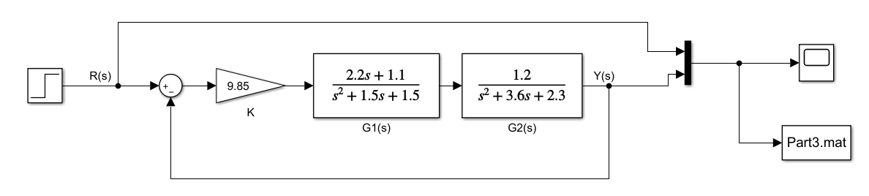

Figure 3: Proportional-Derivative Control SIMULINK Simulation Diagram

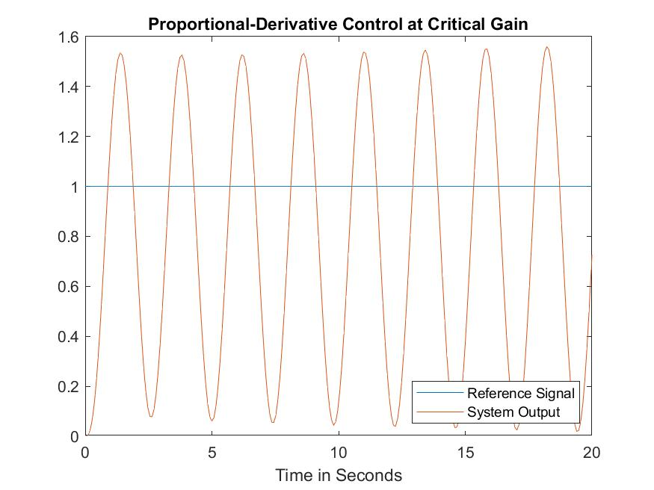

Graph 3: System under Proportional-Derivative Control

$$K_{crit}=9.85$$

$$Frequency=0.42 Hz$$

$$ω=\frac{2π}{T}=\frac{2π}{2.377}$$

$$ω=2.64 rads/s$$

### 3.2 Theoretical Analysis

$G\left(s\right)= G_{1}\left(s\right) ×G_{2}\left(s\right)=\frac{1.32}{s^{4}+5.1s^{3}+9.2s^{2}+8.85s+3.45}$

This system has the same parameters as the Proportional Control except the change in Gain K.

where .

The closed loop gain of a system is calculated below:

Simplified:

The characteristic equation is: $s^{4}+5.1s^{3}+9.2s^{2}+8.85s+3.45+2.64K_{PD}s+1.32K_{PD}$

The necessary condition: $K_{PD}>0$

The characteristic equation is applied in the Routh-Hurwitz array to solve for $K_{{PD}_{CRIT}}$:

Table 6: Routh-Hurwitz for Figure 3

|  |  |  |  |
| --- | --- | --- | --- |
|  |  |  |  |
| $$s^{4}$$ | $$1$$ | 9.2 | 3.45+ ${1.32K}_{PD}$ |
| $$s^{3}$$ | $$5.1$$ | $$8.85+2.64K_{PD}$$ | $$0$$ |
| $$s^{2}$$ | $$7.46-0.517K_{PD}$$ | 3.45+ ${1.32K}_{PD}$ | 0 |
| $$s^{1}$$ | $$\frac{1.36{K_{PD}}^{2}-8.38K_{PD}-48.421}{0.517K_{PD}-7.46}$$ | 0 | 0 |
| $$s^{0}$$ | 3.45+ ${1.32K}_{PD}$ | 0 | 0 |

$$\frac{1.36{K_{PD}}^{2}-8.38K_{PD}-48.421}{0.517K_{PD}-7.46}= 0$$

$$K_{PD}=9.79 \& K_{PD}≠-3.63$$

$$K_{{PD}_{CRIT}}=9.79$$

$K_{PD}$ range: $0<K_{PD}<K_{{PD}_{CRIT}}$

Table 7: Routh-Hurwitz Table when $K_{PD}$ = 9.79

|  |  |  |  |
| --- | --- | --- | --- |
|  |  |  |  |
| $$s^{4}$$ | $$1$$ | 9.2 | 16.37 |
| $$s^{3}$$ | $$5.1$$ | $$34.69$$ | $$0$$ |
| $$s^{2}$$ | $$2.39$$ | 16.37 | 0 |
| $$s^{1}$$ | $$0$$ | 0 | 0 |
| $$s^{0}$$ | 16.37 | 0 | 0 |

The $s^{2}$ row is used to create the auxiliary equation:

$$Q\left(s\right)= 2.39s^{2}+16.37=0$$

$$s= ±j2.61$$

$$ω_{OSC}= 2.61 rad/sec$$

Lastly, to find the Operating Gain, $K_{OPD}$, with a gain margin of $G_{mPD}=4$, it is found to be:

$$K_{Op}=1.798$$

$$G_{mPD}= \frac{K_{{PD}_{CRIT}}}{K_{op}}= \frac{9.79}{1.798}=5.44$$

$$G_{mPD}=5.44$$

## 4 Discussion

|  |  |  |  |  |  |
| --- | --- | --- | --- | --- | --- |
|  | **Simulation** | | **Theoretical** | |  |
|  | $ω_{osc}$**(rad/s)** | **Critical Gain** | $ω_{osc}$**(rad/s)** | **Critical Gain** | **Gain Margin (V/V)** |
| **P** | 1.25 | 7.25 | 1.31 | 7.1946 | 4 |
| **PI** | 1.225 | 6.26 | 1.23 | 6.247 | 3.474 |
| **PD** | 2.64 | 9.85 | 2.61 | 9.79 | 5.44 |

1. Are the theoretical results consistent with your recorded experimental values?
2. How did Kcrit change under different modes of control?
3. How did $ω_{osc}$ change?
4. How did the Gain Margin change under different modes of control?
5. What are the implications of these changes on the relative stability and operation of a control system?
6. For the Proportional Control, the KPCrit of the simulation was 7.26 while the calculated was 7.196. These results are within acceptable deviation and thus can be said that they are satisfactory to the goals of the experiment overall. Any discrepancies in the result come from not sufficiently reducing the gain of the simulation. For the Proportional-Integral Control, the gain of the simulation was 6.26 while the theoretical gain was 6.247. Again, the numbers are within acceptable deviation and can be said to be satisfactory for the experiment. For the Proportional-Derivative Control, the simulation and mathematical results were close to each other and again can be said to be satisfactory to the experiment.
7. The theoretical value of Kcrit between Proportional and Proportional Integral Control differed by 0.94 and between Proportional Integral and Proportional Derivative changed by 3.54. It is noticed that the critical gain drops when switched to Proportional Integral control. The drastic jump from proportional to proportional derivative by almost 73% can be attributed to the multiplication of the numerator of the first transfer function by the time constant.
8. The critical frequency oscillations jump between different modes of control was fairly consistent as with the first switch between the control systems as outlined in the table of summary of results, under theoretical values was 0.08 and the next jump was 1.38. It is to be noted that the trend of the theoretical value of the oscillations drops when switched to Proportional Integral from either of the control systems as it did with the critical gain.
9. The theoretical gain margin was kept changed with each mode of control. The gain margin for Proportional, Proportional Integral and Proportional Derivative was 4, 3.474 and 5.44 respectively. The values calculated were calculated under the assumption that the operating gain should be the same for the last two system controls as the Proportional Control. As was highlighted in the instruction sheet.
10. Relative stability is defined as the rate of how fast the transient response dies out in the system. A measure of relative stability safeguards the system by foreshadowing unstable region by determining whether the closed system poles are right on the imaginary axis. This measure of relative stability is called a gain margin. Throughout the 3 modes of control, the gain margin has been greater than 1, thus making the systems stable. A large gain margin leads to a low operating gain and this has an adverse effect on the quality of the transient system response. For a proportional control system, the response is sped up by large gains which leads to reduction in relative stability and finally to instable system. However, large gains also lead to better steady state errors which is good for the system.